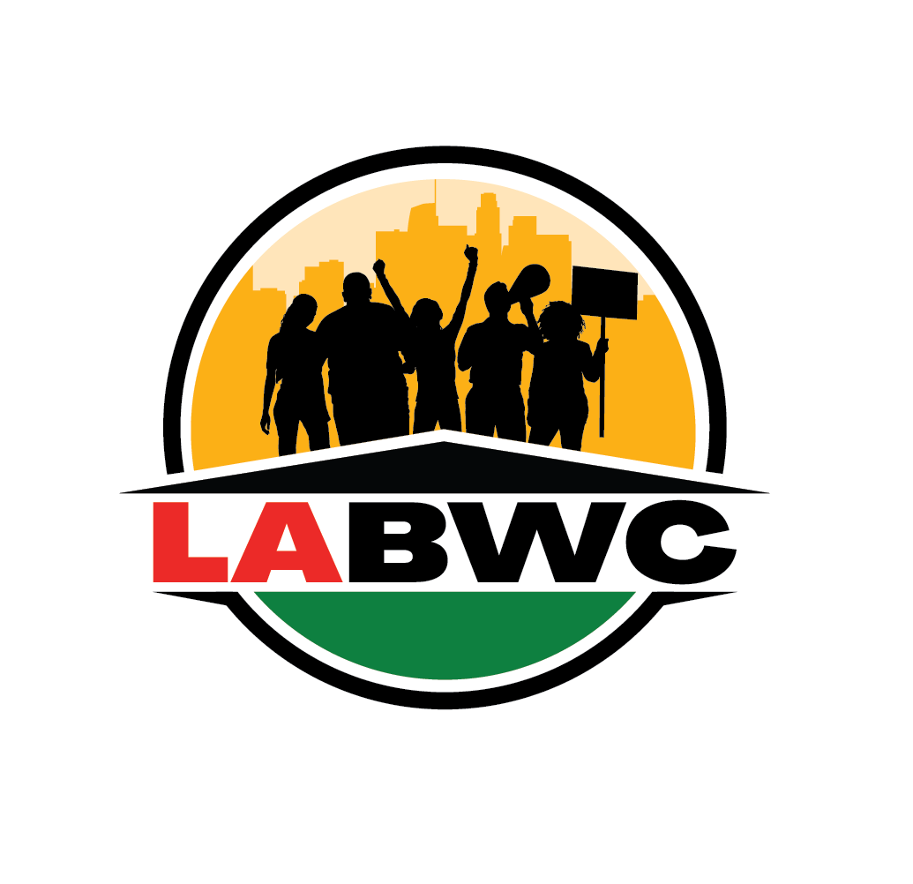

**Campaign Coordinator**

*“We are building a world where Black workers thrive in an equitable economy that sustains and builds vibrant families and communities.”*

The Los Angeles Black Worker Center (LABWC) is a growing organization at the forefront of the racial justice and worker rights movements in LA since 2011. The LA BWC is recognized as a national leader in the effort to address the challenges of the Black jobs crisis of unemployment and underemployment, and the growing inequity in the labor market. The LA BWC works toward economic justice in low-income communities of color by building power amongst Black workers and their communities to expand access to quality employment and promote public policies and corporate practices for sustainable economic development in South Central LA neighborhoods. The LA BWC strategies include a comprehensive approach to: leadership development; political education and training; worker organizing; innovative policy advocacy; coalition building; and comprehensive direct action campaigns that integrate strategic research and communications. The LABWC also provides employment and legal services support.

**DUTIES & RESPONSIBILITIES**

• The day-to-day design, implementation, and management of LA BWC policy/coalitional campaigns at the local and statewide level. This work may include supervising a team that may be 2 or more people to carry all aspects of the campaigns/coalitional work including campaign communications, organizing/engaging community members/volunteers, researchers, legal advisors, community based organizations, and decisionmakers.

• The Campaign Coordinator would report to the Campaign & Coalition Manager who would serve as a thought partner in how to prioritize and carry out the work.

• Strategize and shape comprehensive (research, legal, policy, communications, and grassroots and grasstops field) direct action campaigns that engage members. These campaigns are grounded in fundamental organizing principles and LA BWC’s theory of social change, which is to center the leadership of those most impacted by the Black jobs crisis in the fight for change.

• Identify strategic policy opportunities to advance campaign work. Including but limited to: identifying, educating, and recruiting lawmakers to champion strategic policy; educating lawmakers on policy impacts, monitoring and identifying new and pending policies that impact LABWC constituents.

• Cultivate coalitional and partnership relationships at leadership and staff level with unions, community based organizations and political stakeholders that center Black workers while overseeing the coordination of coalitional activities in a way that deepens the leadership of BWC members and presents opportunities for BWC members to build relationship and knowledge across issue areas reflected in our coalitions.

• Ensure team effectively organizes political and community allies in support of strategic campaigns and civic engagement activities and turnout of community organizations and BWC members to LABWC events;

• Working closely with the Senior lead organizer, to ensure the team meets organizing goals and ID and recruits targeted members to provide on-going support for external advocacy to reach its strategic campaign goals and vision.

• Maintain database and other records on community organizations and leaders in the area;

*Page 2*

• Ensure LA BWC is represented at ally key meetings to maintain effective relationships and build support for LABWC campaigns;

• Coordinate with Communications team to routinely document political and community engagement via Facebook, Twitter, and E-Blast to promote campaigns and coalitional activities and breadth of BWC alliances and power

• Assist organization in growing its dues-paying membership and supports fundraising events.

**MINIMUM QUALIFICATIONS**: Must demonstrate a commitment to social and economic justice through collective/direct action, building collective power for Black workers; managing competing strategic priorities and work in a team environment with the ability to work independently.

• More than two years of experience leading a team with strong delegation and accountability approaches that ensure team plans strategically; can follow a plan, and be accountable to the team in carrying out a plan;

• More than two years of experience facilitating meetings, including agenda creation.

• Experience creating and executing an organizing campaign (with elements of base building, research, legal or regulatory processes, policy, and communications)

• Experience developing and implementing a field plan that allows allies to align self-interest with interest of Black workers through analysis of political landscape that may impact LABWC constituency.

• Ability to respond effectively to conflict as well as bias/“microaggressions” with balanced insight and greater emotional intelligence;

• Strong skills and experience navigating local and state policy processes and advocacy with elected officials; including but not limited to educating lawmakers, navigating policy creation, coordinating local and state lawmaker visits, strategizing to move supporters to action and to identify and neutralize opposition

• Ability to understand and articulate the LA BWC vision, mission, and theory of social change and organize others to align self- interest with the interest of Black workers. Direct experience with the Black jobs crisis is a plus.

• Ability to cultivate and nurture internal and external public relationships that are accountable, reciprocal, and transparent with demonstrated ability to follow up and maintain conversations that advance the work.

• Excellent writing, proofreading, and verbal communications skills. Must be proficient in Google Suite. Must be able to type at least 40 WPM.

• Ability to establish, maintain rapport and work in mutually beneficial coalitions with widely varied ethnic, social and philosophical groups;

• Ability to work under pressure and with minimal supervision; must be a self starter who can lead the team in troubleshooting.

• Established relationships with community organizations and unions in LABWC areas preferred;

**Application Process:** This position is available immediately. Email cover letter and resume to careers@labwc.org, add “Campaign Coordinator” in the subject line. No phone calls, please. Applicants who do not meet the minimum requirements will not receive a response. Full-time position, $30- $34 per hour, plus a comprehensive benefits package that includes medical, dental, vision, life insurance, flexible spending account, and retirement plans with matching and employer contributions to eligible employees!

*LABWC is an equal opportunity employer committed to a diverse and inclusive workforce. In addition, the organization will consider for employment qualified applicants with criminal histories in a manner consistent with the requirements of the Los Angeles Fair Chance Initiative for Hiring. The LABWC is also an affirmative action employer. People of color, women, and LGBTQ are strongly encouraged to apply.*